|  |  |  |
| --- | --- | --- |
| Name:Saurabh Raj Singh | Date:12 May,2022 | |
| Present Address:  Bhairopur,Koilsa,Budhanpur,Azamgarh,U.P. Pin No.- 276142 | Permanent Address:  Bhairopur,Koilsa,Budhanpur,Azamgarh,U.P. Pin No.- 276142 | |
| Mobile:8840538840 | E-Mail ID:Saurabh.singh@vyomlabs.com | |
| Alternate Contact: 9455660530 | Alternate E-Mail ID:10janraj@gmail.com | |
| PAN Card:GCFPS9861C | Source | Direct Applicant |
| Gender : **Male** Female | Vendor/Agency **( Vyom Labs**): |
| Date of Birth (DD/MM/YY):10/01/1997 | Referral (Name & SAPID): |
| LinkedIN |
| Any Backlogs in the Education Yes/ No: No backlog but degree has been extended for 6 months since I dropped one semester due to fever. | Have you Worked in HCL before: Yes / No?  No  If Yes mention your SAP Code : | |
| Skill: ITSM,ARS,CMDB,DWP,Service Portal | 24x7 Work shift - Yes / No : Yes | |
| Total IT Exp. (in Yrs.):2.5 Years + | Relevant Skill Exp. (in Yrs.): | |
| Nationality:Indian | | |
| Category of Position Applied For (To be filled by Recruiter) | | |

Interview Record Form

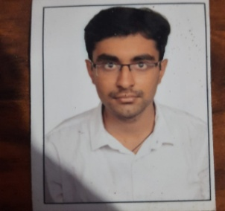

**Ref No: _________________**

**Skill:** ITSM,ARS,CMDB,DWP,Service Portal

|  |  |  |  |  |  |  |  |
| --- | --- | --- | --- | --- | --- | --- | --- |
| **Qualification** | **Degree (Full Time / Part Time / Distance)** | **College / Institute & University** | **Area of Specialization** | **Start Date MM/YY** | **Passed Out MM/YY** | **Grade / %** | **Have Mark Sheet and Certificate YES/NO** |
| X | Full Time | Jeevandeep Public School | CBSE Board-English | April-2011 | March-2012 | 85.5 | YES |
| XII | Full Time | Jeevandeep Public School | CBSE Board-Science | April-2013 | March-2014 | 80 | YES |
| Diploma |  |  |  |  |  |  |  |
| Graduation | Full Time | ICFAI University | Computer Science and Engieering | July 2015 | December-2019 | 73 | YES |
| Post-Grad |  |  |  |  |  |  |  |

# Employment Details: (Starting with your present or most recent employer, please list of all your past employments)

|  |  |  |  |  |  |  |
| --- | --- | --- | --- | --- | --- | --- |
| **Sl.**  **No.** | **Company Name** | **Position Held (While leaving)** | **From**  **(DD/MM/YYYY)** | **To**  **(DD/MM/YYYY)** | **Reasons for leaving** | **Offer letter (OL)/ Relieving letter (RL)/ Experience Certificate (EC)**  **Please Tick If you have** |
| 1 | Vyom Labs | Remedy Developer | 20th July,2021 | Till Date |  | OL / RL / EC |
| 2 | Intelliplanar Software Pvt Ltd | Full Stack Web Developer | 1st Feb,2021 | 12 June,2021 | Better Oppurtunity | OL / RL / EC |
|  |  |  |  |  |  | OL / RL / EC |
|  |  |  |  |  |  | OL / RL / EC |
|  |  |  |  |  |  | OL / RL / EC |
| **Technical Certifications** : | | | | | | |

### 

|  |  |  |  |  |
| --- | --- | --- | --- | --- |
| **CTC Details** | Fixed Comp: | Variable Comp: | Additional Allowance | Total Annual CTC |
| Expected CTC: | | Notice Period: | | |

**Declaration:**

I, ____________Saurabh Raj Singh___________________ declare that the information provided by me above is true to the best of my knowledge and belief. Any misinterpretation or omission in above details renders me liable and I will abide the action taken by the company.

**Cab consent:**

I, ___________Saurabh Raj Singh____________________ hereby acknowledge and understood HCL’s cab policy that I can avail cab facility only if the residence is within 35Kms radius and will re-locate within this distance if cab is required.

**Date: 12-05-2022**

**Digital Signature:**

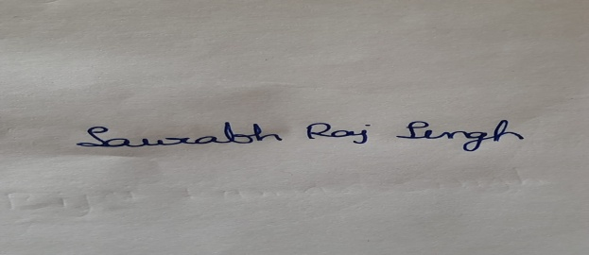

**Place:Azamgarh**